Biology, Castle View High School
Jason R Mayberry, PhD
Study Guide: Chemical Reactions
Vocabulary:
- Physical Change
- Chemical Reaction
- Reactants
- Products
- Reaction Equation
  - Coefficients
  - Subscripts
  - Balanced
- Chemical Energy
- Exergonic Reactions
- Endergonic Reactions
- Energy of Activation
- Intermediate State
- Catalyst
- Enzyme
Conceptual Questions
- Describe what happens to molecules during a chemical reaction.
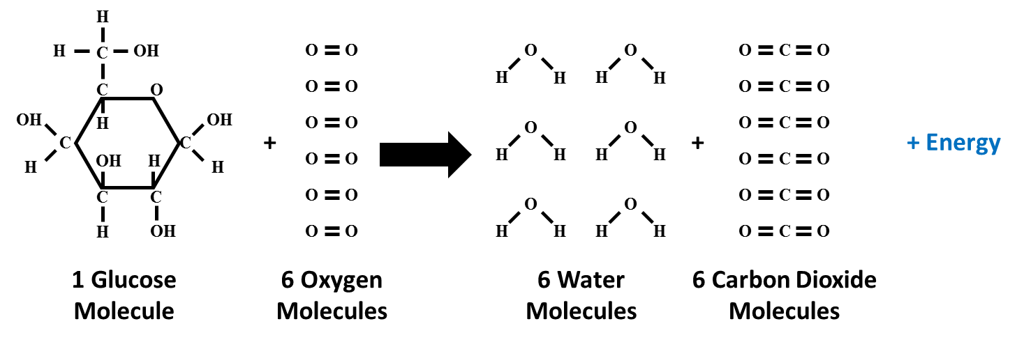
- Describe how a reaction equation depicts what happens in a chemical reaction. What does it mean for a reaction equation to be balanced?

- Write the reaction equation for the chemical reaction depicted below.
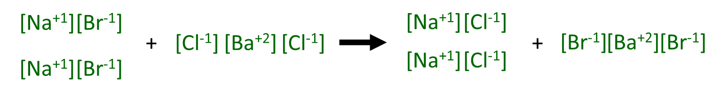

- Generally speaking, describe what happens during a chemical reaction to absorb or release energy? (i.e. what is the source of energy in the molecules?)
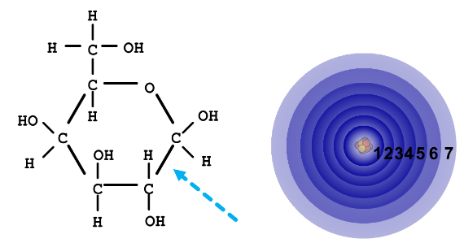
- How do High Energy Chemical Bonds differ from Lower Energy Chemical Bonds?

- Describe how the energy changes during exergonic and endergonic reactions (i.e. draw a graph for each).

- What is physical reason that the Energy of Activation is needed to initiate a chemical reaction, even exergonic ones?
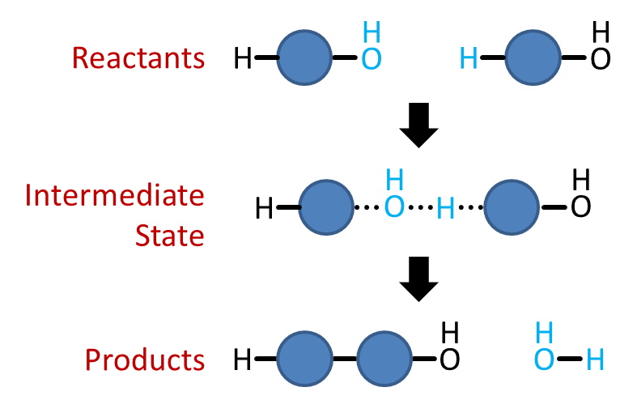
- How does a catalyst increase the rate of a chemical reaction?

